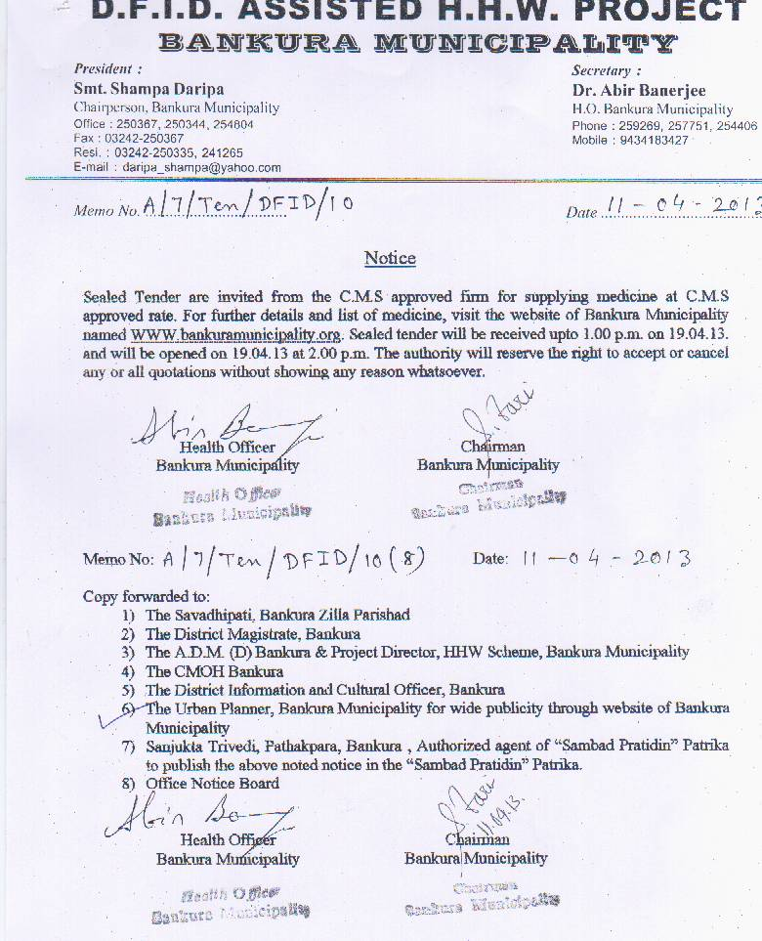

List of Medicine

Sl No | Name of the Medicine | Quantity Required
1 | Metronidiazole 400mg | As per official requirement
2 | Combined Gastric Antacid | Do
3 | Ranitidine 150 mg | Do
4 | Paracetamol 500mg | Do
5 | Folifer (small) | Do
6 | Domperidone 10mg | Do
7 | O.R.S. Citrate | Do
8 | Ibuprofen 400mg | Do
9 | Albendazole 400 mg | Do
10 | Dicyclomine 20mg | Do
11 | Povidone Iodine Ointment 15 gm | Do
12 | Benzyl Benzoate Lotion 100 ml | Do
13 | Cotirmoxazole (Adult) Sulphamethoxazole400mg & Trimethoprim 80mg | Do
14 | Vitamin B-Complex | Do
15 | Co-trimoxazole (Paediatric) Sulphamethoxazole 200mg & Trimethoprim 40mg | Do
16 | Ciprofloxacine | Do
17 | Cholorpheniramine Maleate 4mg | Do
18 | Eye aplicap 1% w/w in aplicap. Each aplicap to contain 250mg of oint | Do
19 | Absorbent Cotton 100 gm each | Do
20 | Absorbent Gauze | Do
21 | Microspore | Do
22 | Antiseptic Lotion | Do
23 | Bromhexine | Do
24 | Folifer (large) | Do
25 | Cotrimoxazole (suspension) | Do
26 | Amlodipine | Do
27 | Vitamin A oil | Do

Sd/- Sd/-
Health Officer Chairman
Bankura Municipality Bankura Municipality

